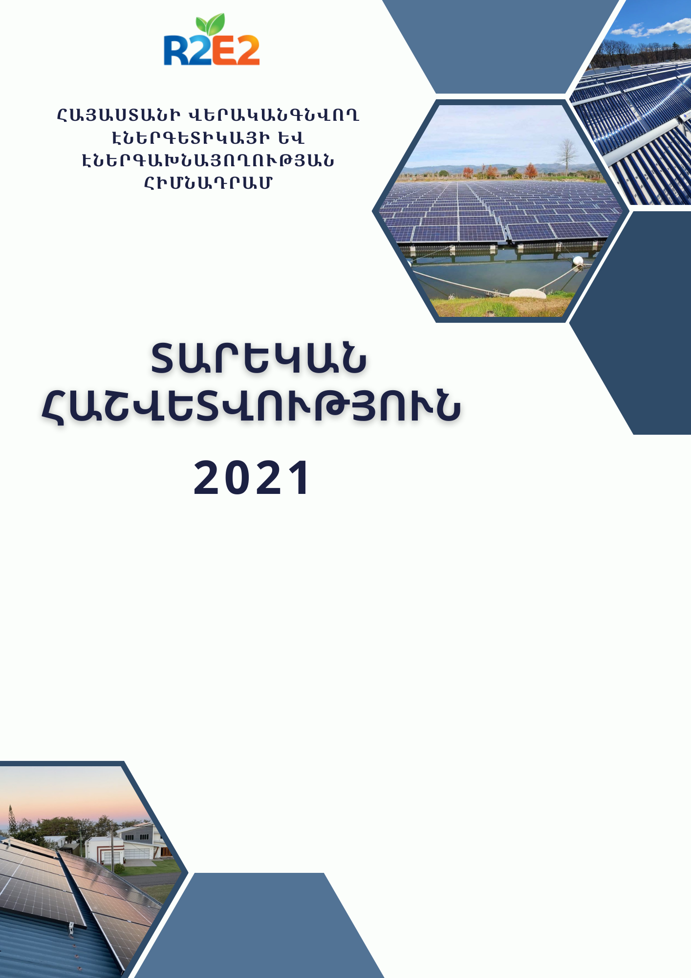



**RENEWABLE RESOURCES AND ENERGY EFFICIENCY FUND OF ARMENIA**

ANNUAL REPORT

2021

**ՏԱՐԵԿԱՆ ՀԱՇՎԵՏՎՈՒԹՅՈՒՆ**

##### About us

**Mission and vision of the Foundation**

The mission of the Renewable Resources and Energy Efficiency Fund of Armenia is to promote the implementation of energy-saving programs and the development of renewable energy sources.

R2E2 Fund is a renewable energy and energy efficiency organization that promotes best practices in sustainable energy to increase energy security and independence in Armenia.

**Structure of the Fund**

The management bodies of the Fund are the Board of Trustees and the Director of the Fund. The Board of Trustees (BoT) is the supreme governing body of the Fund, with overall authority for the strategic management of the Fund in accordance with its stated goals and operating principles. The Board of Trustees (BoT) consists of representatives of public administration authorities and qualified specialists of the state and public sectors with relevant knowledge and experience. The representative composition of the Board of Trustees is determined by the Charter of the Fund. Tigran Avinyan is the Chairman of the Board of Trustees of the Fund. The Board consists of 9 members.

The Director of the Fund shall exercise the powers defined by the legislation and the Charter of the Fund. Karen Asatryan has been director of the Fund for 2021. In 2021, the Fund had a professional staff of an average of 20 people per year.

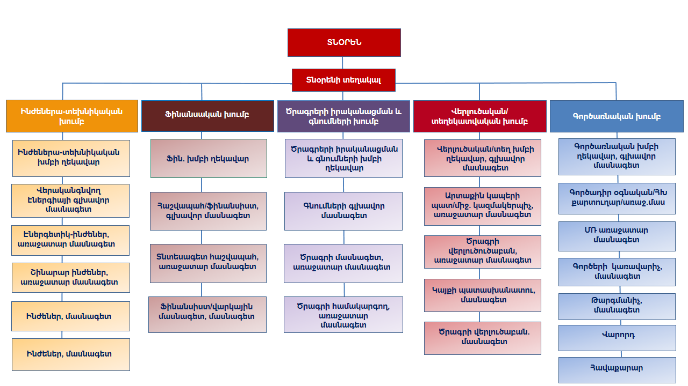

**Composition of the Fund Board of Trustees**

|  |  |
| --- | --- |
| Tigran Avinyan | Chairman of the Board of Trustees |
| Hakob Vardanyan | Deputy Minister of Territorial Administration and Infrastructure of the Republic of Armenia |
| Garegin Baghramyan | Chairman of the RA Public Services Regulatory Commission |
| Hasmik Kahramanian | Member of the Board of the Central Bank of the Republic of Armenia |
| Romanos Petrosyan | Head of the RA State Supervision Service |
| **Armen Ghularyan** | Chairman of the RA Urban Development Committee |
| Ani Ispiryan | Deputy Minister of Economy of RA |
| Mikhail Martirosyan | Chairman of the Association of Legal Entities "Armenia Energy Services Provider Association" which supports the development of Armenia's energy sector |
| Astghine Pasoyan | Director of the "Foundation to Save Energy" |

Anna Melik-Israelyan is the secretary of the Board of Trustees of the Fund. 2021 During the year, the Fund organized 14 meetings of the Board of Trustees (BoT), during which numerous decisions concerning the Fund's activities were discussed and approved.

Projects

##### **UTILITY-SCALE SOLAR POWER PROJECT**

***General project description:***

In 2015, the Republic of Armenia and the International Bank for Reconstruction and Development signed a $2.5 million grant agreement to commence the "Utility-scale Solar power" project.

Currently, with the support of EBRD R2E2 Fund is selecting potential sites.

In 2022, with the help of a transaction advisor, the R2E2 Fund will select an international investor to build solar power plants with a capacity of up to 150 MW.

These are pre-selected sites

* Vardenis
* Artsvanist
* Gegamasar
* Talin

Significant reductions in the cost of solar photovoltaic (PV) technology in recent years and the resulting reduction in the capital investment required to build solar plants have made electricity generation using photovoltaic technology more competitive than electricity generation using other technologies.

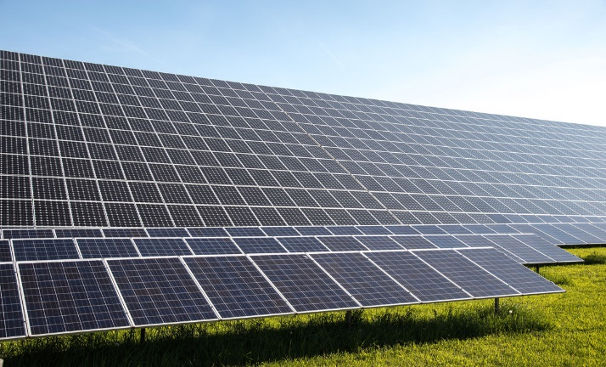Today it is already possible to obtain a competitive tariff for industrial PV installations in the Electricity System of Armenia that does not have a negative impact on end-users. Favorable conditions will make it possible to build solar photovoltaic stations on an industrial scale in Armenia and attract the world's leading companies in the field of solar energy to the country's energy market.

##### **PROJECT of Solar Photovoltaic power "AIG-1" 200 MW**

The Renewable Resources and Energy Efficiency Fund of Armenia, at the proposal of the Ministry of Territorial Administration and Infrastructure of the Republic of Armenia, has selected a private company or consortium to implement the "Aig 1. 200 MW Solar Photovoltaic (PV) Power Plant Industrial Project in Armenia"(Project) to design, finance, build, own and operate a solar photovoltaic (PV) power plant. The project site is located on the territory of Talin and Dashtadem communities of Aragatsotn Region of the Republic of ArmeniaGovernment of the Republic of Armenia 2019 According to Decree No. 1922-L of December 26, 1945, the Project shall be implemented by one company (Project Company) established for this purpose in accordance with the Design, Financing, Build, Own, and Operation (DFBOO), which shall be jointly owned by the Selected Applicant (85% ownership) and the Armenian National Interests Fund (ANIF) (15% ownership).

“Abu Dhabi Future Energy Company” PJSC (“Masdar”) was selected through a tender in accordance with international standards. PJSC ”Abu Dhabi Future Energy Company” offered a tariff of $0.0290/kWh.

A delegation led by “Abu Dhabi Energy Company” PJSC ("Masdar") signed the Agreement on state support for 2021. November 26.

##### FLOATING SOLAR PV PLANTS

" The Renewable Resources and Energy Efficiency Fund and the French organization (TRANSENERGIE) have developed a "program for the development of floating solar PV plants in Armenia," as a result of which the French government approved a grant of 800,000 euros on December 11.

The program was launched on February 25, 2021. A list of all lakes and artificial reservoirs on the territory of Armenia with their main characteristics has been developed. Thereafter, three tanks had to be selected from this list, taking into consideration technical, environmental, and other issues. As a result of joint discussions with the Fund and TRANSENERGIE Company, the following reservoirs were selected: Azat reservoir (Ararat Region), Aparan reservoir (Aragatsotn Region), and Yerevan reservoir (Yerevan).

The project included a feasibility study for a demonstration solar plant for selected 3 reservoirs.

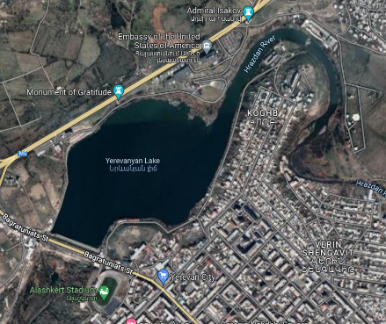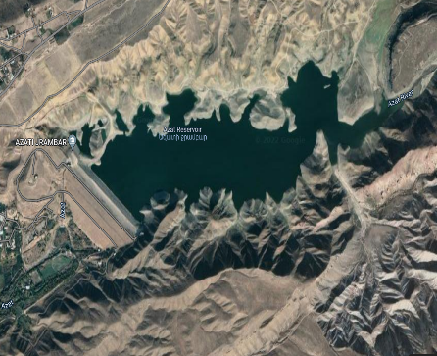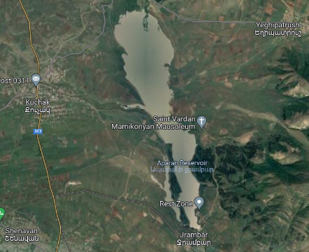Based on these feasibility studies, Lake Yerevan was selected as a suitable reservoir for the project.

Aparan reservoir

Azat reservoir

Yerevan reservoir

It is planned to build a solar photovoltaic plant with an installed capacity of about 150 kW in the selected reservoir, which will be connected to the distribution network.

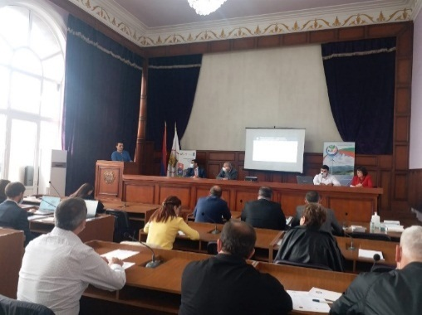Following the selection of Lake Yerevan as the design water reservoir, the Fund, in collaboration with ՛՛JINJ՛՛ Ltd, conducted a Social Impact Assessment (SIA) at the plant, according to which no significant environmental or social impacts are expected during the construction and operation of the plant.

On October 6, 2021, a public discussion was organized together with the Yerevan Municipality in the Shengavit administrative district of Yerevan, to which almost all interested parties were invited and attended, the project was presented and all solutions and problematic issues were discussed. As a result, considering the impact of the station's position on the preparation and conduct of canoeing competitions, it was decided to amend the draft design, which will resolve all disagreements with the sports school. A floating solar photovoltaic station is currently being designed and is expected to be completed in August 2022, with construction scheduled for September.

##### “nATIONAL PROGRAM ON ENERGY SAVING AND RENEWABLE ENERGY FOR 2021-2030 AND TRIENNIAL ACTION PLAN FOR THE FIRST PHASE OF ITS IMPLEMENTATION”

The Renewable Resources and Energy Efficiency Fund of Armenia commissioned by the UNDP has developed a "National program on energy saving and renewable energy for 2021-2030 and triennial action plan the first phase of its implementation".

The project involves analyzing the previous national energy project of the Republic of Armenia, evaluating its effectiveness, as well as identifying problems and modeling solutions for the next 10 years.

The first phase of the "Energy saving and Renewable Energy of the Republic of Armenia for 2010-2017" project was implemented.

Within the framework of the contract, The Renewable Resources and Energy Efficiency Fund collaborated with the AVAG SOLUTIONS and the SCIENTIFIC RESEARCH INSTITUTE.

Renowned advisors in the field were also involved in the development of the project

The cost of the project is $89,500, which was approved on March 26, 2020, and in 2021 It was submitted to the RA Government for approval at the end of the year.

##### PILOT EE PROJECT IN SCHOOLS OF ARAGATSOTN, KOTAYK, GEGHARKUNIK, AND SHIRAK REGIONS OF THE RA

According to the RA Prime Minister's instruction № 02 / 12.2 / 51800-2019, and the BoT resolution- 05/20 dated 30.07.2020, Armenia Renewable Resources and Energy Efficiency Fund implemented the EE project at its own expense in the schools selected from Aragatsotn, Kotayk, Gegharkunik and Shirak regions of the RA

The capacity of the plants was selected based on the amount of electricity consumed by the schools, which provides 100% savings. The objective of the project is to help schools reduce electricity bills, have a sustainable and clean source of energy, rereducearbon dioxide (CO2) emissions, and have educational value, the pilot project aims to introduce methods and efficiency of renewable energy without risk.

**12-MONTH RESULTS OF INSTALLED SOLAR POWER PLANT**

|  |  |  |  |  |  |  |  |  |  |  |  |  |  |  |  |  |  |  |
| --- | --- | --- | --- | --- | --- | --- | --- | --- | --- | --- | --- | --- | --- | --- | --- | --- | --- | --- |
| հ/հ | Region | Community | Object Name: | Installed power:  kW կՎտ | Amount of energy produced by month, kWh | | | | | | | | | | | | Only in 2021. kWh  kWh! | Greenhouse:  Gas reduction, CO2-tonnes |
| **01․21** | **02․21** | **03․21** | **04․21** | **05․21** | **06․21** | **07․21** | **08․21** | **09․21** | **10․21** | **11․21** | **12․21** |
| 1 | **Aragatzotn** | **Mastara** | **Միջնակարգ դպրոց ՊՈԱԿ** | **10** | **900** | **1023** | **1083** | **1491** | **1983** | **1910** | **1721** | **1769** | **1625** | **1338** | **993** | **870** | **16706** | **7․2** |
| 2 | **Shirak** | **Aygabac** | **Միջնակարգ դպրոց ՊՈԱԿ** | **5** | **308** | **432** | **532** | **693** | **909** | **828** | **893** | **812** | **728** | **541** | **382** | **318** | **7376** | **3․2** |
| 3 | **Kotayk** | **Zoravan** | **Միջնակարգ դպրոց ՊՈԱԿ** | **5** | **405** | **442** | **468** | **712** | **912** | **937** | **921** | **849** | **757** | **625** | **455** | **416** | **7899** | **3․4** |
| 4 | **Gegharkunik** | **Ttujur** | **Միջնակարգ դպրոց ՊՈԱԿ** | **5** | **387** | **571** | **571** | **689** | **734** | **803** | **633** | **771** | **575** | **502** | **431** | **446** | **6898** | **3․0** |
|  | **Total** |  |  | **25** | **2000** | **2654** | **2654** | **3585** | **4538** | **4478** | **4168** | **4201** | **3685** | **3006** | **2261** | **2050** | **38879** | **16․8** |

*Savings are calculated on the basis of 47.98 drams per 1 kWh.

1. 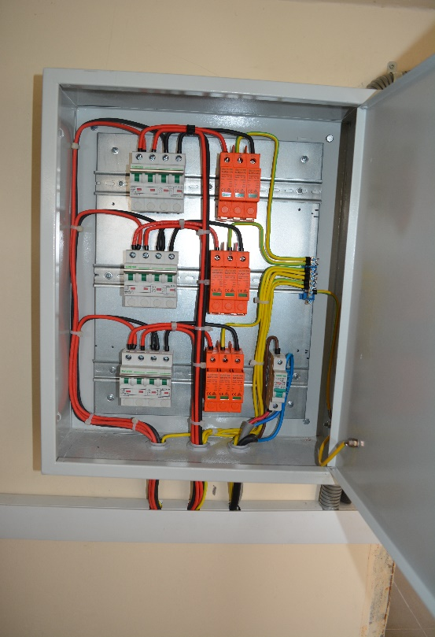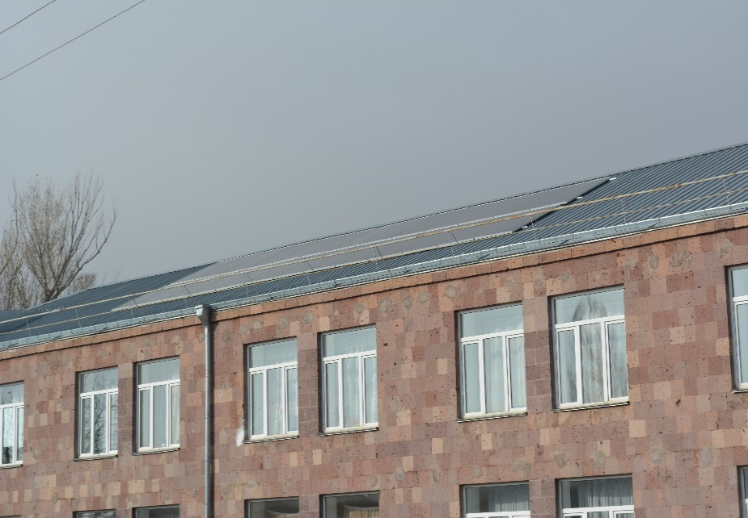**Aragatsotn Region**. The 10 kW rooftop plant at Mastar secondary School produced 16,706 kWh of electricity in 2021.
2. **Shirak Region**. A 5kW rooftop substation at Aigabatsi secondary School in Shirak region produced 7,376 kWh of electricity in 2021

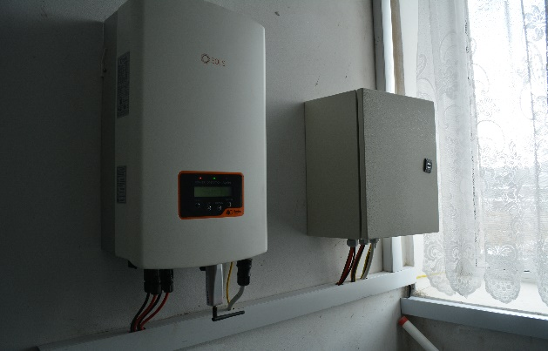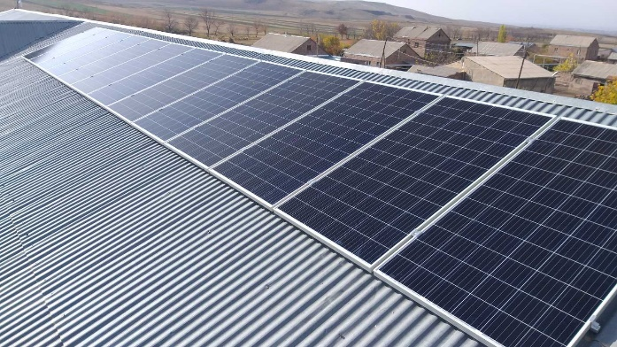

1. **Kotayk Region**. The 5 kW rooftop substation at Zoravan secondary in Kotayk region produced 7,899 kWh of electricity in 2021.
2. **Gegharkunik Region**. The 5kW rooftop substation of the Ttuira secondary School in Gegharkunik region produced 6.9 kWh of electricity in 2021.

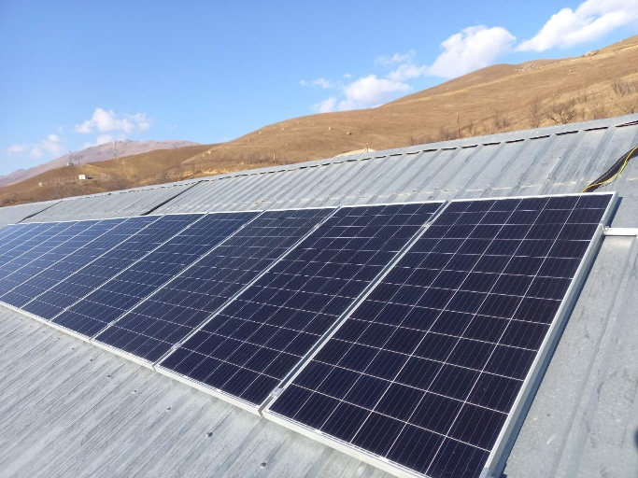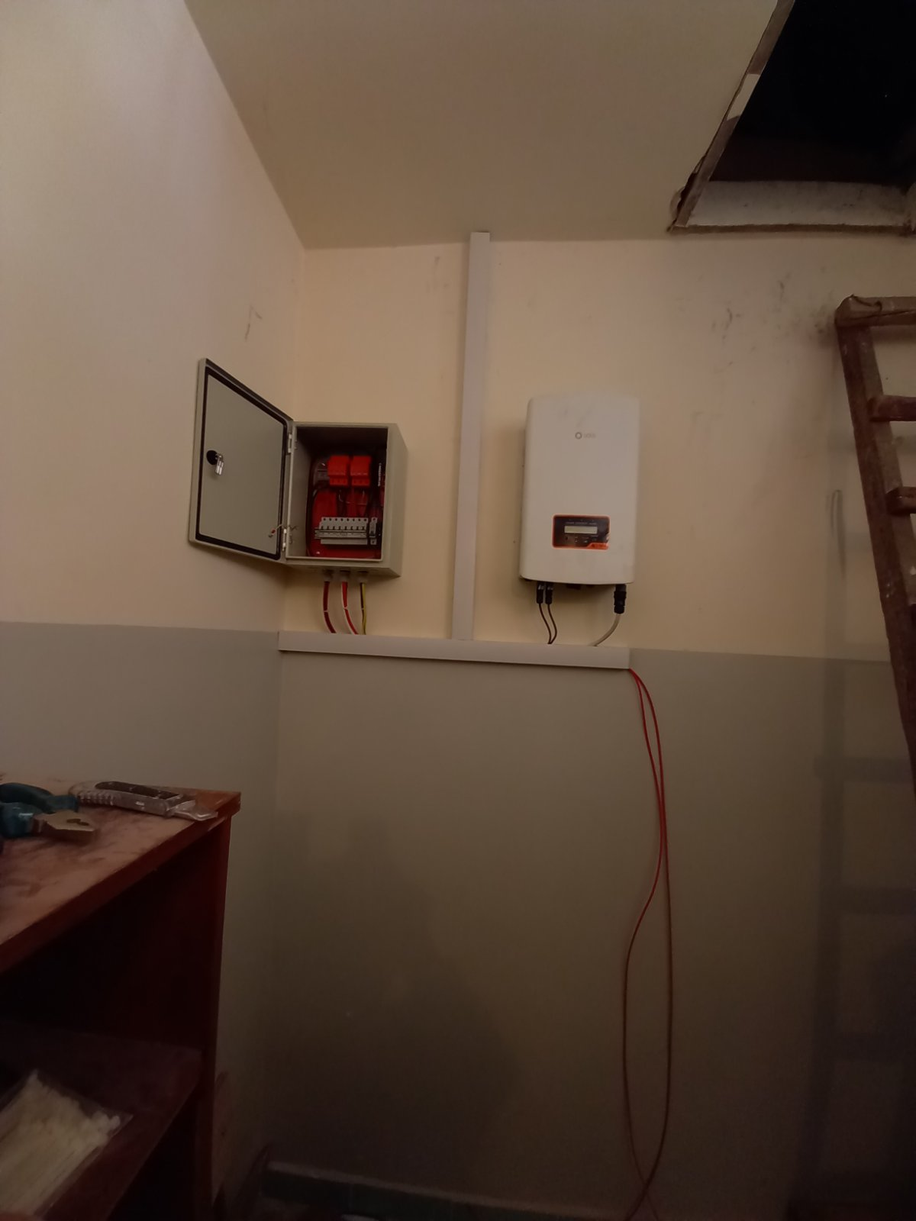

It was expected that in 2021 the total annual capacity of solar plants in the 4 schools would be about 36,000 kWh, but it turned out to be about 39,000 kWh.

##### “GREEN” SKILLS FOR YOUTH PRoject

The Renewable Resources and Energy Efficiency Fund of Armenia collaborate with the NGO “Women in Climate and Energy”, NGO which implements the "Green Skills for Youth" project funded by UNDP and GEF. As part of the project, the Fund supported and implemented energy-efficiency measures for two schools.

The main objective of the "Green" Skills for Youth project is to raise students' awareness of climate change mitigation and green technologies. Thus, students will be involved in evaluating the energy consumption of their schools, as well as in improving the energy efficiency of buildings.

The Renewable Resources and Energy Efficiency Fund of Armenia have installed 10 kW in Gyumri elementary school No 7 in the Shirak Region of RA with the latter's funds in 2021 within the framework of the "Green Skills for Youth" project, and in the Yerevan Solar photovoltaic installations with a capacity of 7 kW in A. Pushkin elementary school No. 8. The cost of the project is 6,197,000 drams.

*Characteristics of installed photovoltaic plants and expected results*

|  |  |  |  |  |  |  |
| --- | --- | --- | --- | --- | --- | --- |
| Community | Region | Name of the object | Installed power in watts | Annual production capacity, kWh | Savings, money | Reduction of greenhouse gas emissions, CO2 - tons |
| Gyumri | Shirak | Gyumri Elementary School No. 7 | 10 | 15500 | 743,690 | 6.7 |
| Yerevan |  | А. Pushkin Elementary School No. 8 | 7 | 10500 | 503,790 | 4.5 |
| Total | | | **17** | **26000** | **1247,480** | **11.2** |

Below is a detailed description of the work done by the schools.

1. 21 solar photovoltaic modules with a capacity of 480 watts and a 10kW grid converter were delivered and installed for Gyumri Elementary School No. 7 in the Shirak region. The modules are installed on the roof, all electrical connections are made, and the system is integrated into the school's electrical network. 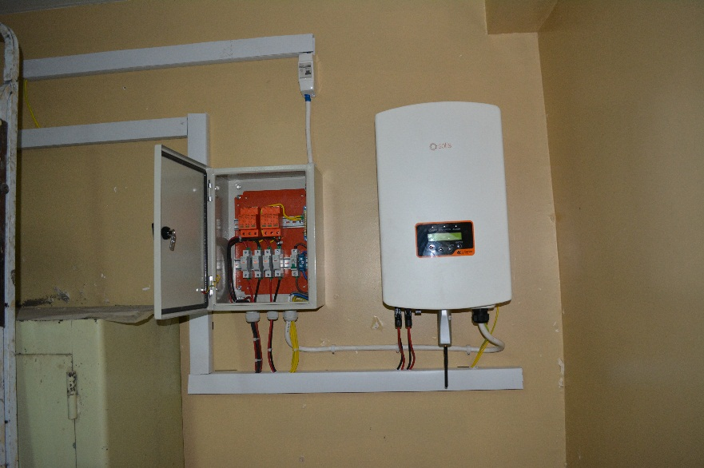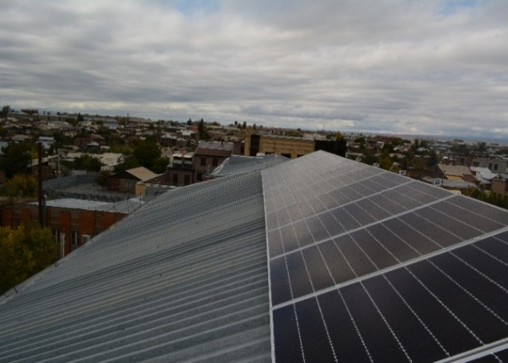
2. Yerevan 16 solar photovoltaic modules with a capacity of 455 W and one grid converter with a capacity of 7 kW were supplied and installed for A. Pushkin Elementary School № 8. The modules are installed on the roof, all electrical connections are made, and the system is integrated into the school's electrical network.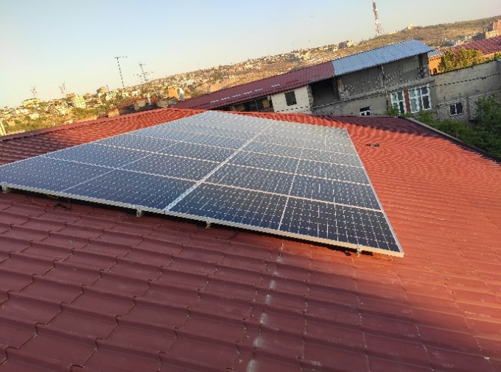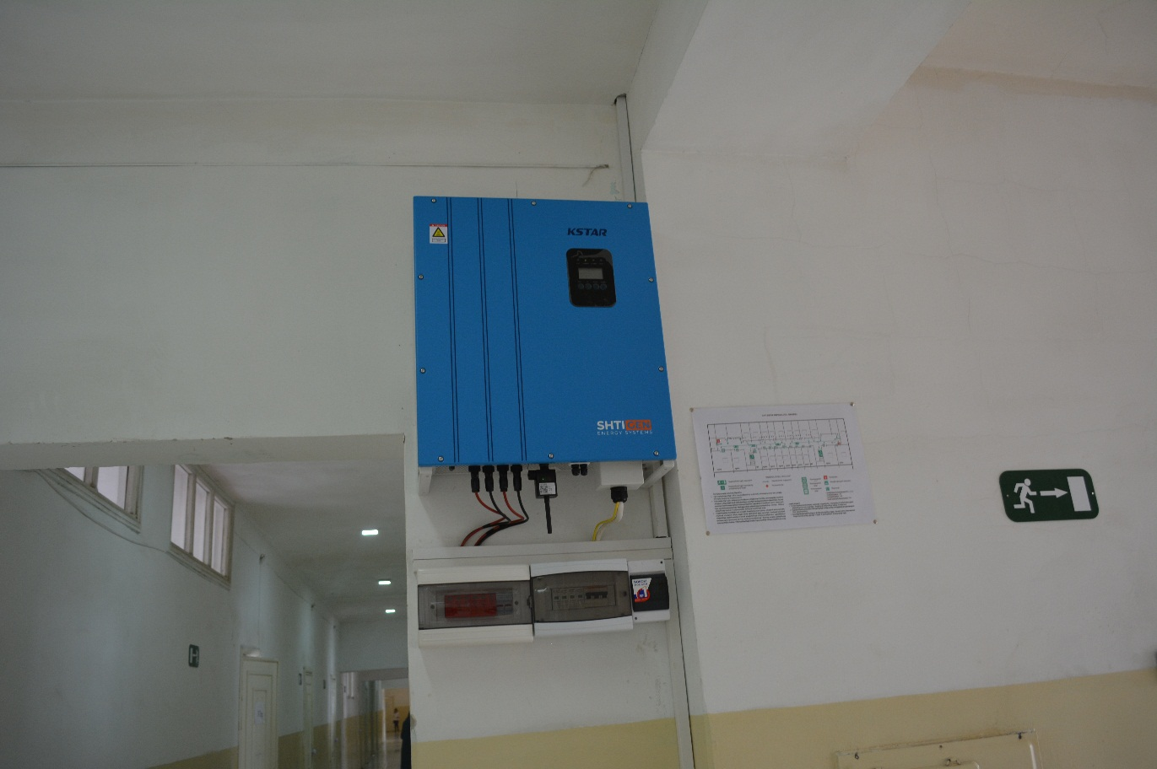

##### **“GREEN ECONOMY FINANCING facility” PROJECT**

‘’The Green Economy Financing facility project is developed and financed by the European Bank for Reconstruction and Development (EBRD).

The objective of the project is to finance "green investments" in business through affordable credit. Lending is done through four project financial facilities in Armenia.

Within the framework of the project, the Fund conducts energy audits and certification of borrowed projects within the scope of the agreement of 13.02.2018, signed with the German organization IPC (Internationale Projekt Consult GmgH).

In 2021, Fund experts studied the installation of 10 photovoltaic plants and confirmed their implementation. The total capacity of these photovoltaic plants is 3,334 kW and will produce about 5.2 million kWh of electricity per year. Green investments amounted to 3,899 drams ($1,964,315), and CO₂ emissions would be reduced by about 2,232 tons.

Within the framework of the same project, Fund specialists conducted a preliminary energy audit of energy efficiency projects to install four photovoltaic power plants and modernize one production facility. The total capacity of the photovoltaic plants is 1,860 kW. All five projects will save about 2.9 million kWh of energy per year. The investment will be $1,304,053 and CO₂ emissions will be reduced by about 1,286 tons.

##### **ENERGY EFFICIENCY IMPROVEMENT PROJECT FOR NON-GASIFIED, BORDER, AND OTHER COMMUNITIES IN RA**

In 2017, The Renewable Resources and Energy Efficiency Fund launched the "Energy Efficiency Improvement Project for legal entities and individuals in non-gasified communities of Armenia," which aims to encourage individuals and legal entities to invest in renewable energy through a financial institution. Initially, the project was aimed at about 280 non-gasified communities in Armenia, including about 37,000 households.

Later (starting in 2020) the project was extended to all communities of the Republic of Armenia.

Loans are available to beneficiaries of non-gasified and border communities at an annual interest rate of 8% and to beneficiaries of gasified communities at an annual interest rate of 10%. The maximum term of the loan is 8 years. The fund refinances financial institutions at an annual interest rate of 4-6%. In the case of corporate financing, the financial institution co-finances 20% of the loan amount.

To implement this project, the Fund cooperates with a number of financial institutions, including OJSC "ACBA Bank", "Global Credit" UCO, "Acba Leasing" CO, "Agroleasing LVC", "Armenian Leasing Company " UCO, "Fast Credit Capital" UCO and "Evokobank" CJSC.

In 2021, specialists of the Fund gave a positive opinion on the credit for the installation of 112 solar water heaters and 74 solar photovoltaic systems․ The reduction in CO2 emissions was 542.5 tons.

##### **COMMUNITY ENERGY EFFICIENCY Improvement PROject**

The objective of the Community Energy Efficiency Improvement Project, implemented jointly by The Renewable Resources and Energy Efficiency Fund of Armenia and Commercial Bank ACBA BANK JSC in 2017, is to ensure that Armenian communities invest in energy efficiency through concessional financing. The project also aims to reduce inefficient energy consumption and expand the use of clean, efficient, safe, and affordable energy technologies. In order to implement energy efficiency measures in the community, investments are repaid from additional amounts generated by energy savings, so that the implemented project is not an additional burden on the community's budget.

In 2021, energy efficiency projects were completed in Goravan, Mrganush, and Kanachut communities, and in the Karbi community, the projects are in the construction stage.

*Summary table of work performed in 2021*

|  |  |  |  |
| --- | --- | --- | --- |
| Community | Measure | Quantity | Investment,  AMD |
| Goravan | Measures of the EE in pre-school educational institutions (PEI) |  | 3,700,000 |
|  | Outdoor lighting, light fixture, pcs. | 386 | 22,460,000 |
|  | The photovoltaic system, kW | 60 | 21,552,000 |
| Mirganush | The photovoltaic system, kW | 30 | 9,537,780 |
|  | Outdoor lighting, light fixture, pcs. | 20 | 334,980 |
| Spitak | Outdoor lighting, light fixture, pcs. | 302 | 43,482,512 |
|  | Photovoltaic system, kW | 70 | 19,392,000 |
| Mrgashen | Modernization of the PEI heating system |  | 11,988,468 |
| Total |  |  | 132,447,740 |

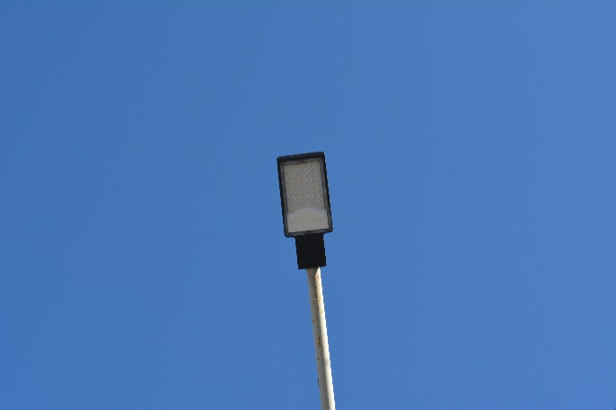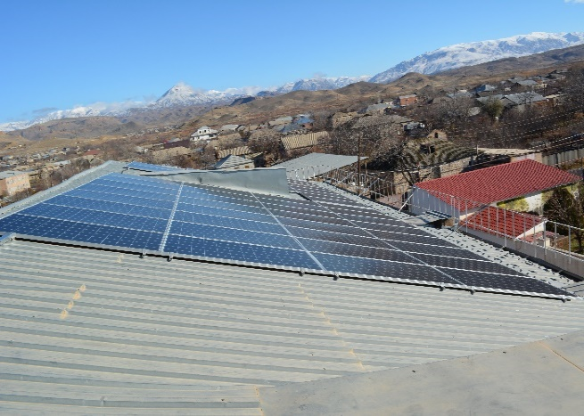 Investments made 132.5 million drams, an annual saving of energy - 452,193 kWh, and an annual reduction of CO2 emissions - 216 tons

Goravan Community, Outdoor Lighting

Goravan Community, Solar Photovoltaic Station

Investments made 132.5 million drams, an annual saving of energy - 452,193 kWh, and an annual reduction of CO2 emissions - 216 tons.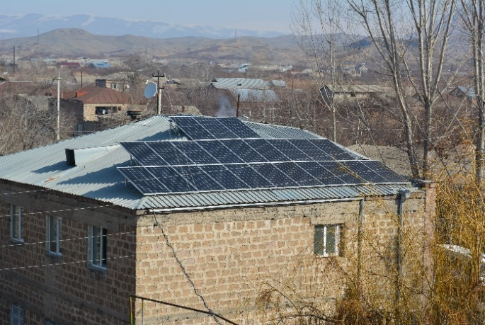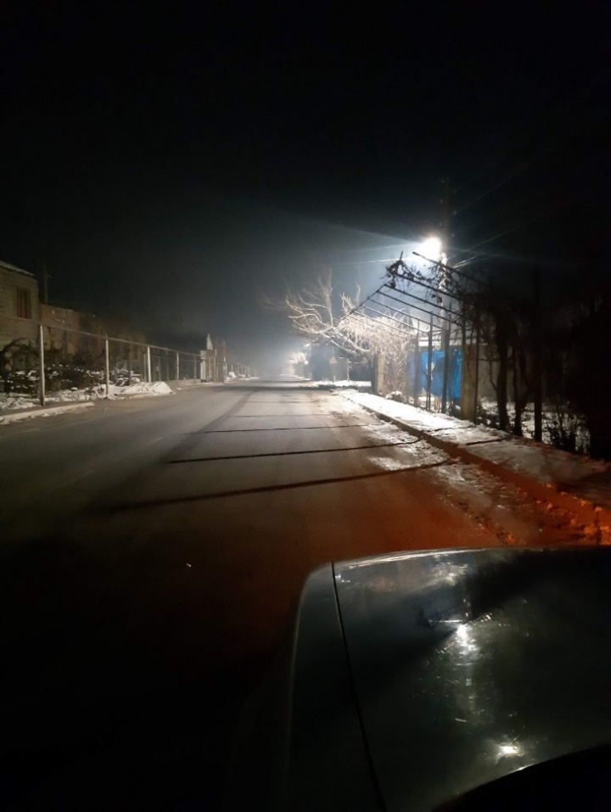

Mrgashen Community, a solar photovoltaic plant

Mrgashen Community, Outdoor Lighting

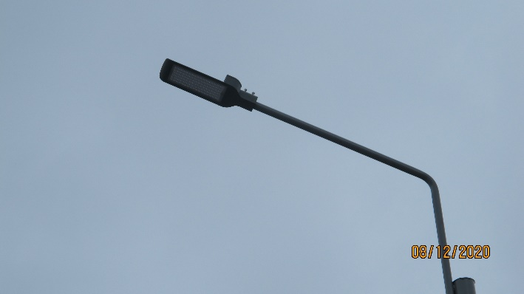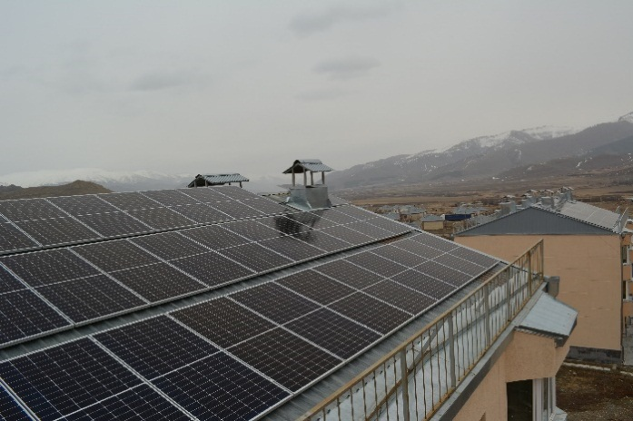

Սպիտակ համայնք, արտաքին լուսավորություն

Spitak Community, a solar photovoltaic plant

Spitak Community, Outdoor Lighting

##### **“Green energy and energy efficiency improvement in public buildings “ project eurasian fund for stabilization and development (EFSD)**

The Fund 2018 applied for a grant to implement a project of mechanisms to promote “Green energy and energy efficiency improvement in public buildings”․ The cost of the project is 2,071,277 USD (grant from EDF - 1,719,200 million USD, co-financing of the Government of the Republic of Armenia - 352,077 USD).

**The expected results of the project are;**

* Twenty public buildings (school, kindergarten, hospital) will see a 50% increase in energy efficiency, resulting in savings of 3,000 MWh of electricity per year and a reduction of 700 tons of carbon dioxide emissions per year.
* Development and support of infrastructure entities that provide energy services
* Raising the awareness of energy sector representatives of at least 20 regional administrations about the mechanisms of attracting loans for energy saving and energy efficiency.

In 2021, the Fund, in partnership with the Eurasian Fund for Stabilization and Development (EFSD), negotiated a grant agreement and prepared the prerequisites for its entry into force. The project commenced in the second quarter of 2022.

The return on investment for the implementation of energy efficiency measures is provided by additional sums generated as a result of energy-saving, which ensures that the implemented project is not an additional burden on the budget of the community and the state structure.

**Support the EBRD green technology transfer platform in Armenia to accelerate circular economy activities**

The European Bank for Reconstruction and Development (EBRD) uses the Green Technology Selector (GTS) list to facilitate SME financing and lending projects. The list includes various technologies by category.

The Renewable Resources and Energy Efficiency Fund of Armenia is implementing a project to expand the Armenian list of "High-Efficiency Technologies" commissioned by the EBRD.

The objective of the project is to expand the existing list of "High-Efficiency Technologies" for Armenia with new categories and relevant technologies for local SMEs with high potential for a closed-loop economy, as well as to identify viably, but under-represented sustainable closed-loop technologies. in the Armenian market, they are not on the list of Green Technologies in Armenia due to the lack of an appropriate product category and methodology. The cost of the project is 74,990 euros

The project's objective is to expand the list of " High-Efficiency Technologies " available for Armenia with new categories and relevant technologies that have a high potential for a closed-loop economy for local SMEs and to identify viable but inefficient technologies for a sustainable closed-loop economy that are not well represented in the Armenian market, and are missing from the list of Green Technologies of Armenia due to a lack of an appropriate product category and methodology. At the end of the project, the list of green technologies in Armenia will be supplemented with new categories of technologies and sustainable technologies in accordance with the approved methodology, specifications, and minimum efficiency criteria. The cost of the project is 74,990 euros

SMEs can take advantage of the list and find more efficient (energy-saving, high-efficiency) technologies when purchasing technologies for their needs. In the case of inclusion in the list, each technology is issued an electronic certificate stating that it has high efficiency. If these technologies are used, it is possible to obtain co-financing from loans or, in some cases, even from the EBRD on the most favorable terms.

***The following works were carried out within the framework of the project***

* Areas of the industry with great potential for a closed-loop economy have been studied and discovered,
* The study identified technologies widely used in the observed industries with high potential for efficiency gains, which were included in four new categories for inclusion in the Armenian "High-Efficiency Technologies " list.
* The studies summarizing the results of the study directions are developed by studying the literature on the directions, Internet resources, and regulatory documents, as well as by communicating with relevant market players and relevant authorities.

*Green Technology Selector*

The Green Technology Selector platform is a multilingual online information system that assumes low emissions, climate resilience, and other environmental benefits based on technical and environmental performance in accordance with the EBRD's minimum efficiency standards. The Green Technology List is designed to stimulate investment in the green economy in EBRD countries, in particular through local financial institutions. The Green Technology List plays a key role in facilitating the commercialization of environmentally friendly technologies and the expansion of measures to combat climate change by financial institutions. With this tool, small and medium-sized entrepreneurship (SMEs), households can purchase environmentally clean technologies, and financial institutions can easily create and offer green financing opportunities, saving transaction costs and time.

##### **/EU4ENERGY EFFICIENCY/**

Within the financing of the "European Union for Sustainable Energy in Armenia" project (EU4ASEP), the Fund carried out technical supervision of the construction of a 600 kW solar plant in the Artik community of Shirak marz.

The Project's objective is to improve energy efficiency in residential buildings, particularly in non-gasified communities residing with vulnerable households with low-income and multi-apartment residential buildings and public facilities. R2E2 Fund will act as a one-stop-shop and will be responsible for:

* boosting energy efficiency investments in public facilities and multi-apartment buildings;
* Technical assistance and risk mitigation
* Technical assistance in project design
* Competitive procurement procedures,
* Construction control
* Technical monitoring and control over energy savings and financial proceeds.
* Implementing pilot projects with innovative and large-scale energy-saving solutions (including grants).

**The cost of the project is $15 million.** The commencement of the project has been postponed because of COVID-19 to the second half of 2022.

##### **“RENEWABLE ENERGY DEVELOPMENT” PROJECT**

In 2018, the German-Armenian Renewable Energy Development Fund's loan project was commenced. The project also provides loans for the construction of solar photovoltaic power plants up to 500 kW for self-sufficiency through the financial institutions of RA.

In 2021, within the framework of the agreements signed between the 5 companies using this project and the R2E2 Fund, Fund’s experts conducted a study of the submitted documents and the site of solar photovoltaic plants, providing a report with the relevant conclusions and recommendations. Within the framework of the agreement signed between the Fund and Fichtner GmbH & Co KG, specialists from the Fund evaluated the documents and proposals submitted for the construction of four photovoltaic power plants and submitted a report with the corresponding conclusions and recommendations. The total capacity of these photovoltaic plants is 1,580 kW, which will save about 3.09 million kWh of energy annually, and CO2 emissions will be reduced by about 1,355 tons. The project is financed by the German Development Bank KfW.

##### 

##### **ACCREDITATION TO THE GREEN CLIMATE FUND**

"TRAINING ASSISTANCE" FOR THE NEEDS OF POTENTIAL ACCREDITATION CANDIDATES FOR PROject EVALUATION, ENHANCEMENT, AND CAPACITY

To gain accreditation with the Green Climate Fund (GCF), the Fund received a grant to improve the Fund's Operational Manual, as well as to develop summaries of two projects for submission to the GCF. The cost of the project is **$254,000.**

* After accreditation, the Fund will be able to implement up to 50 million U.S. dollar-funded projects, as well as subgrants.
* The accreditation process is expected to be completed **in 2022.**

Within the framework of the project in 2021 purchase/implementation of the following consulting services:

* The first consultation service involves identifying the Fund's procedural gaps and developing measures to address the latter. The contract was awarded to Global fields (England). The company developed a GSF-compliant report and presented the results of the assignment through a workshop/training session.
* The second objective is to develop a schedule of activities that meets the Fund's core standards, including the development of environmental, social, and gender guidelines. Grant Thornton CJSC (Armenia) was chosen to perform the objective. The company has developed GCF-compliant documents, the results of which will be summarized in 2022 and presented as a seminar/course.

##### **PROJECT "EXPERT STUDY OF THE FINANCIAL AND TECHNICAL FEASIBILITY OF biomass plants"**

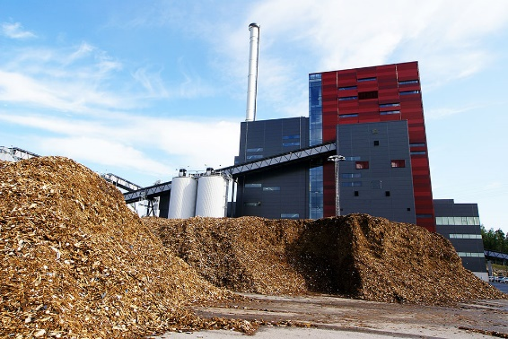The Renewable Resources and Energy Efficiency Fund of Armenia partnership with the "Clean Energy Solutions" (CES) Gmbh, an Austrian company is conducting an expert study on the financial and technical feasibility of biomass plants, as well as providing support and training for private investors. The agreement was signed on March 24, 2021. The cost of the task performed by the fund is 25,050 euros.

The scope of the project included the following tasks:

* Assessment of the conditions of the legislative and legal framework for the use of biomass for power generation in Armenia,
* Implementation of an overall financial and technical feasibility study for biomass projects for power generation in Armenia
* Identification of up to 5 pilot projects for the use of biomass for power generation in Armenia,
* Planning the support and training needs of the Armenian partners within the measure,
* Determination of biomass utilization efficiency indicators

The project is scheduled for completion in July 2022.

##### **Energy audit for the construction of 5mw solar PV plants service agreement**

In 2021, within the framework, a service agreement between the Fund and companies licensed to build a solar photovoltaic power plant, energy studies of solar photovoltaic plants up to 5 MW were carried out.

|  |  |  |  |
| --- | --- | --- | --- |
| Plant name | Power kW | Expected annual production volume  million kWh | Annual CO2 emission reductions  tons |
| Helios 1 | 5000 | 15.428 | 6․665 |
| Helios 2 | 5000 | 15.368 | 6․639 |
| Helios 3 | 5000 | 14.950 | 6․458 |
| Helios 4 | 5000 | 13.276 | 5․735 |
| Limar Green | 1230 | 2.501 | 1․051 |
| Total | 21230 | 61․523 | 26,548 |

An energy audit involves:

* Verification of documents provided by companies,
* site visit and land assessment,
* Calculation of solar potential and an assessment of the electricity that will be generated,
* Assessing the feasibility of investments
* evaluation of financial and economic indicators
* Preliminary assessment of the expected results of the project
* Preparation of the relevant report and submission to the customer.

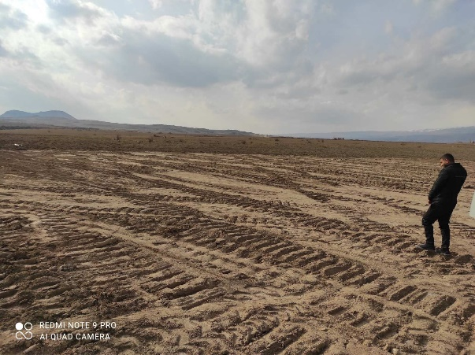 Investments in solar photovoltaic plants will total $15.4 million, annual electricity production will be 61.5 million kWh, and the reduction in CO2 emissions will be about 26,548 tons.

In addition, the following solar photovoltaic plants up to 5 MW have undergone ongoing energy studies within the scope of the service agreement between the companies building the Fund's solar photovoltaic plants.

**"A-S ENERGY" LLC**

|  |  |  |  |
| --- | --- | --- | --- |
| Plant name | Power kW | Expected annual production volume  million kWh | Annual CO2 emission reductions  tons |
| A-S Energy | 5000 | 9.25 | 3996 |
| Prom Sintez | 5000 | 11.65 | 5032 |
| Total | 10000 | 20․9 | 9028 |

The current energy audit involves:

* Verification of documents provided by companies
* visit to the construction site,
* Assessment of completed work
* Assessment of purchased and delivered goods,
* Assessment of financial flows for the construction of the station,
* Preparation of the relevant report and submission to the customer.

The solar photovoltaic plants will have an investment of $6.7 million, an annual electricity production of $20.9 million kWh, and a reduction of CO2 emissions of about 9,028 tons.

##### **ASSESSMENT OF 2021 SUBVENTION PROJECTS FOR THE ECONOMIC AND SOCIAL INFRASTRUCTURES DEVELOPMENT OF THE RA COMMUNITIES**

Within the framework of the Assessment of 2020 subvention project for the economic and social infrastructures development of the RA communities, experts of the Fund have studied the packages of project applications for subvention communities in 2021, submitted for consideration by the Inter department Commission, established by the decision of the Prime Minister's Decree of March 19, 2019 № 278-A on solar PV installations and street lighting systems and conclusions on the design and estimate documentation are presented.

|  |  |  |
| --- | --- | --- |
|  | Information about the conclusions given by the Fund in 2021 | |
| 1 | Just a package of subvention for discussion | 192 |
| 2 | Number of communites included in the subvention packages presented for discussion | 142 |
| 3 | Only a conclusion was given | 194 |
| 4 | Conclusion given for a solar photovoltaic PV system | 88 |

The objective of the project is to support the financing of energy efficiency measures in small and medium-sized enterpreneurship in Armenia. Within the framework of the project in 2021, the Fund conducted 40 energy studies. Lending was done through 5 financial institutions and included the following sectors: industry, food production, air conditioning, health care, refrigeration, transportation, etc.

ADVAISORY SERVICES

##### **PROVISION OF ENGINEERING AND CONSULTING SERVICES ENERGY EFFICIENCY FINANCE FOR MSMES EITH THE GERMAN-ARMENIAN FUND (gaf)**

The main indicators of the SME Energy Efficiency Financing Support Project by year are shown in the table below.

|  |  |
| --- | --- |
| Name | 2021թ |
| Number of appeals with a positive conclusion, statement | 40 |
| Amount of loan granted million drams | 1,641.645 |
| Investments in EEM, million drams | 2,127.061 |
| Expected energy savings, kWh | 1,345,930 |
| Energy Efficiency%. | 47.1 |
| CO2 emissions reduction, tons | 599.956 |

Development of design-estimate documentation

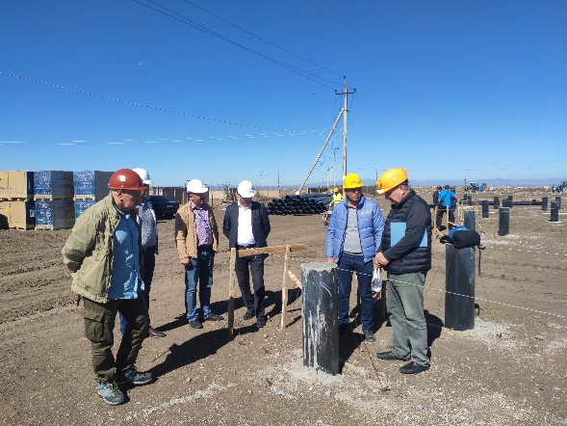 Within the framework of the Agreement «ԳՄՄՀ-ՀՄԱԾԶԲ-21/11» signed between the Fund and the Martuni municipality of Gegharkunik region, the Fund implemented (in 2020 the Fund obtained a license for the project from the Committee for Urban Development of RA) Development of design and estimate documentation for solar photovoltaic plants with an installed capacity of 15.64 kW and 25.76 kW and supervision over the construction and installation works of the plants.

**IMPLEMENTATION OF TECHNICAL CONTROL**

The main objectives of the agreement with the European Union are:

1. Develop the institutional capacity of R2E2 and turn it into an established center that can effectively assist in investment planning, manage energy efficiency projects, serve as an energy information data center, evaluate and analyze energy efficiency and energy efficiency investments, and implement investment projects and other measures within its mission;
2. Provide legal assistance to ensure full or partial compliance with building energy efficiency legislation, as outlined in the Comprehensive and Enhanced Partnership Agreement to Encourage Investment in Public and Residential Buildings.
3. Raise the Armenian society's awareness of energy efficiency/energy efficiency and the financial instruments available in the market.

Between the Energy Saving Support Fund and the R2E2 10.06.2020 Within the framework of the agreement №ESF/CS/ST-2021/001 signed in 2010, the Fund's experts carried out technical supervision over the construction of a 600 kW solar photovoltaic power plant in Artik.

FINANCIAL REPORT

Information about the activities of the Fund is reflected in the financial statements of the Fund, which is submitted to the Ministry of Territorial Administration and Infrastructure, the Ministry of Finance, the Board of Trustees of the Fund, and donor organizations.

The Fund prepares financial accounting and financial statements in accordance with International Financial Reporting Standards. The financial statements of the Fund, as well as the financial statements of the implemented projects, are subject to an annual mandatory external audit. The costs of the activities carried out by the Fund, as well as the functions assigned to it by the Charter, are covered by the annual maintenance costs approved by the Board of Trustees of the Fund, and the annual consolidated budgets of the implemented projects.

The Fund, as a non-profit organization, has diversified sources of income. The Fund implements relevant measures to manage and mitigate risks and ensure stability and continuity.

The fund's income consists of grants, interest on loans from financial institutions, and consulting services in local and foreign markets. The Fund implements energy-saving investment and loan projects at the expense of working capital, the main source of which is borrowed funds attracted from the Ministry of Finance of RA under the agency agreement.

The Fund is constantly expanding its range of services, diversifying its loan portfolio, and participating in new grant projects.

The annual financial report of the Fund together with the auditor's report shall be published by June 30 of the following year on the website <https://www.petekamutner.am> and on the website of the Fund.

Only in 2021, the Fund provided loans worth 263,336,030 drams to financial organizations.

|  |  |  |
| --- | --- | --- |
|  | The total amount of credit | AMD |
| **1** | GLOBAL CREDIT UCO CJSC | 557,025,000 |
| **2** | ACBA LEASING VC CJSC | 476,240,050 |
| **3** | ACBA-CREDIT AGRICULTURAL BANK CJSC | 470,344,812 |
| **4** | ARMENIAN LEASING COMPANY UCO | 48,619,742 |
| **5** | AGROLEASING LCC. LLC | 67,709,000 |
| **6** | FAST CREDIT UCO CJSC | 10,631,700 |
|  | **Total** | **1,619,938,604** |

**THE AGENCY OF THE MINISTRY OF FINANCE OF THE RA**

Below is information about the amounts received from the Ministry of Finance under the agency agreement between the Ministry of Finance of RA and The Renewable Resources and Energy Efficiency Fund of Armenia dated July 30, 2012.Գ Based on the agreement signed between the RA Ministry of Finance and the Renewable Energy and Energy Saving Fund of Aria on July 012, below is information about the funds received from the Ministry of Finance.

|  |  |
| --- | --- |
| RA Ministry of Finance | |
| AMD | **US dollar** |
| 1,740,568,346 | 4,737,831 |

Measures

**Pre-bid teleconference for the investment project of the 200 MW Aig-1 solar photovoltaic plant in Armenia**

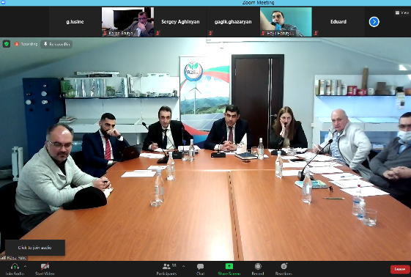A pre-bid teleconference of the Utility-scale project of 200 megawatts Aig-1 solar photovoltaic plant organized by The Renewable Resources and Energy Efficiency Fund of Armenia was held on January 25 in Armenia. Hakob Vardanyan, RA Deputy Minister of Territorial Administration and Infrastructure, Karen Asatryan, Director of The Renewable Resources and Energy Efficiency Fund of Armenia, and Sergey Aghinyan, representative of the Public Services Regulatory Commission, made welcoming remarks at the opening of the teleconference.

The teleconference was attended by representatives of pre-qualified companies, members of the tender commission, representatives of the consulting company for the deal, companies representing the energy sector of Armenia, international financial organizations, and other guests. During the teleconference, Melik Gasparyan, Senior Solutions business consultant, presented project preparation, basic bidding procedures, minimum technical requirements, land issues, and schedule. Representatives of pre-qualified companies were given the opportunity to ask questions and get clarification from other participants in the teleconference.

We would to remind you that a 200 MW Aig-1 solar photovoltaic station is planned to be built in the Talin and Dashtadem administrative districts of the Aragatsotn Region.

  A tender was announced for the design, financing, construction, own, and operation of the plant. The winner will be the company that offers the lowest rate.

**GCF Readiness and preparatory Support Program; “Readiness Support for accreditation gap assessment, capacity building and pipeline development for potential accredited entity”**

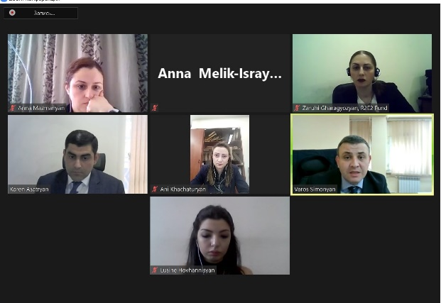

On March 11, under the chairmanship of RA Deputy Minister of Environment Anna Mazmanyan, the first meeting-discussion of the council was held under the chairmanship of "Preparing the needs assessment of the potential organization-candidate for accreditation, capacity building, and development of a package of projects" funded by the Green Climate Fund and implemented by the Armenian Renewable Resources and Energy Efficiency Fund.

During the meeting, Karen Asatryan, Director of R2E2, informed the Board about the launch of the project and presented the objectives of the project. All agenda items were approved, in particular the procurement plan and schedule.

**Exhibition "Caucasus․ Construction and Repair EXPO 2021” exhibition**

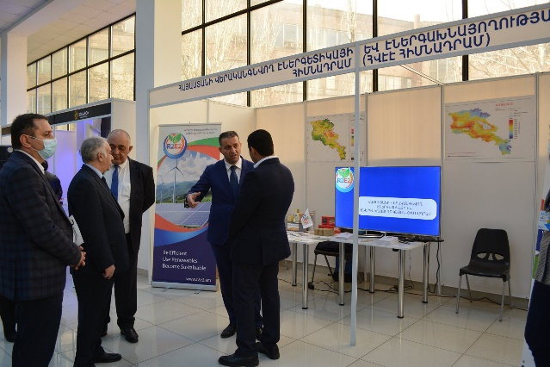

On March 25 commenced the largest 17th international specialized exhibition in the region “CAUCASUS. CONSTRUCTION AND REPAIR EXPO 2021” exhibition organized by The manufacturers and businessmen of Armenia and [LOGOSEXPO](https://www.facebook.com/hashtag/logosexpo?__eep__=6&__cft__%5b0%5d=AZWNklIxntTmue5fNW2Y0OAjrO8KfULMDH2l9d9OwI2Zzde7zB3RKWWgawxXqSXR-y3qMv-n0vIJGgUq0OqQ6EvQqXonU5MZjZCfiyTvvk0w9U3hzwLyxfFjrPkQLUXsv1MS-w_OhwX8cbNMdNS-gLN1Vr7bs7IVNZYHZmMVadi20GG_S1ej2GHMO7Nuhw91a_w&__tn__=*NK-R) Center company.

The partner of the exhibition is also The Renewable Resources and Energy Efficiency Fund of Armenia. The fund participates in a three-day exhibition with its own pavilion, which features various videos about the fund's activities, information about the services it provides, and energy-saving materials.

The traditional annual “CAUCASUS. CONSTRUCTION AND REPAIR EXPO 2021” the 17th International specialized exhibition, the largest construction exhibition in Armenia, is an excellent incentive to strengthen the business ties of participating organizations, enhance prestige, develop business, as well as enrich information about the construction market.

Exhibitors are more than 90 local and foreign companies, leading market investors, construction, consulting, and design companies.

**Working trip**

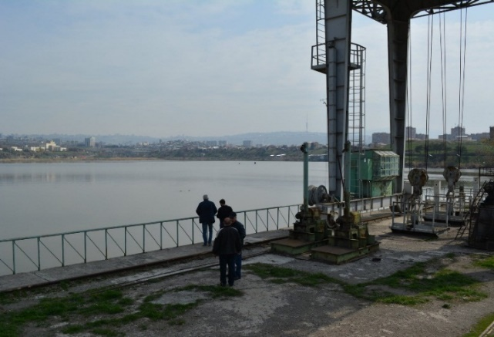On April 8, within the framework of his trip, he had meetings with the director of SNCO "Center of expertise for environmental impact assessment", and with the Chief of the Department of nature protection of Yerevan Municipality Georg Nazaryan where were discussed about Armenian basin`s environmental issues, legislative acts, and other issues. Together with specialists from the Fund, they visited three pools to study the sites, construction, and operation of the plant.

We would like to rremind you that within the framework of the project it is planned to study the existing reservoirs in Armenia and the technical and financial possibility to build and operate solar power plants floating on them, after which a pilot floating solar photovoltaic plant with a capacity of about 150 kW will be built.

**Opening of the meeting of technical proposals for the project of the 200 MW Aig-1 solar photovoltaic power plant**

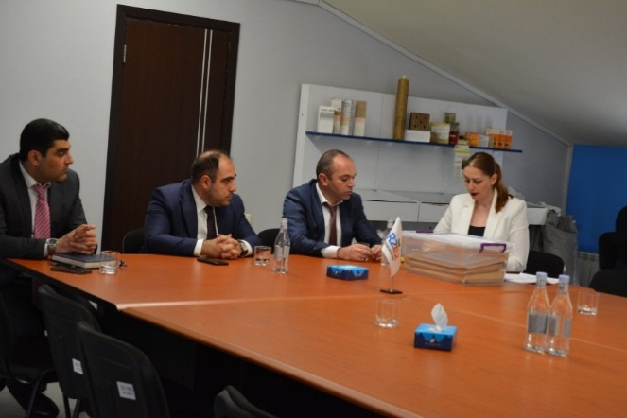

A technical proposal meeting for the 200 MW Aig-1 solar photovoltaic project was opened on April 9.

The committee members headed by RA Deputy Minister of Territorial Administration and Infrastructure Hakob Vardanyan took part in the session.

**Steering Committee Meeting of the "Innovative Solutions for Achieving Sustainable Development Goals in Armenia" Project**

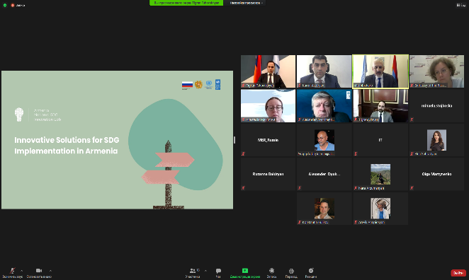On April 28, an online meeting of the Steering Committee of the "Innovative Solutions for Achieving Sustainable Development Goals in Armenia" Project was held.

RA Deputy Prime Minister, Co-Chairman of the Board Tigran Avinyan, Chief of Staff of the RA Deputy Prime Minister, Deputy Chairman of the Board Bagrat Badalyan, UN Resident Coordinator in Armenia Shombi Sharp, Council Vice President Michaela Stoykoskaya representative, and representatives of other international organizations.

 Karen Asatryan, Director of the R2E2 Fund, presented the activities of the R2E2 Fund as part of the "Innovative Solutions for Sustainable Development in Armenia" project.

**"Green Skills for Youth**

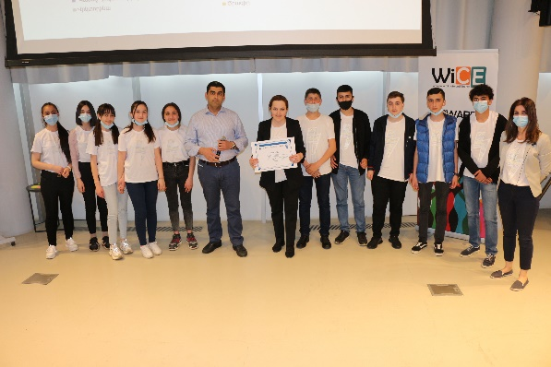The "Green Technology for Youth" project of the NGO "Women in Climate and Energy" and funded by the UNDP-GEF Small Grants Project "Green Technology in Schools" held a measure at the Smart Center Lori Region Children of Armenia (COAF) titled․ Members of the "green team" of ten regional schools participating in the project, physics teachers, and principals attended the measure.

The main objective of the project is to raise awareness in schools about climate change mitigation actions, and green technologies, involving students in evaluating the energy consumption of their schools and improving the energy efficiency of buildings.

The project was intended to allow only four schools to implement the proposed projects, but The Renewable Resources and Energy Efficiency Fund of Armenia joined the initiative to implement the proposed project at another school.

For the projects submitted by the winning schools, the schools were awarded an energy-saving certificate of 2 million drams for the implementation of energy efficiency measures within the framework of the "Green Skills for Youth" project.

**The signing of the agreement**

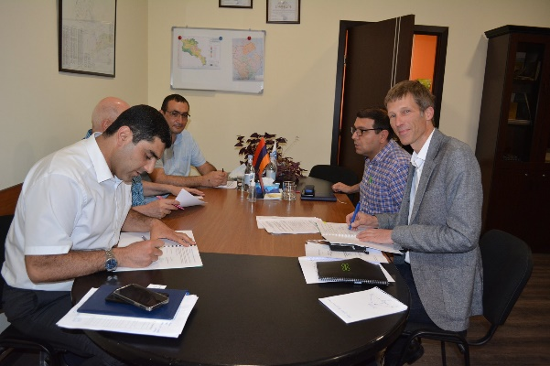

On May 10, Karen Asatryan, director of The Renewable Resources and Energy Efficiency Fund of Armenia, and Sven-Malte Storing, Project Manager of the German Fichtner Company signed an agreement within the framework of the German-Armenian Fund's "Promotion of the fourth phase of the Renewable Energy Project," which plans to support the construction of solar photovoltaic plants up to 500 kW in capacity.

The Fund will provide technical assistance, etc.

**Working trip**

Philippe Jean, an ecologist from the French company PJN-Consulting, came to Armenia to see the project work on site. During his trip, he had meetings with the director of SNCO "Center of expertise for environmental impact assessment", and with the Chief of the Department of nature protection of Yerevan Municipality Georg Nazaryan, where they discussed environmental problems of Armenian basins, and legislative norms, and other issues. Together with experts from the Fund, they visited three reservoirs to study the sites, construction, and operation of the plant.

We would like to rremind you you that within the framework of the project it is planned to study the existing reservoirs in Armenia and the technical and financial possibility to build and operate solar power plants floating on them, after which a pilot floating solar photovoltaic plant with a capacity of about 150 kW will be built.

**Meeting-discussion of the investment project of solar photovoltaic installations "Aig-1" with a capacity of 200 MW**

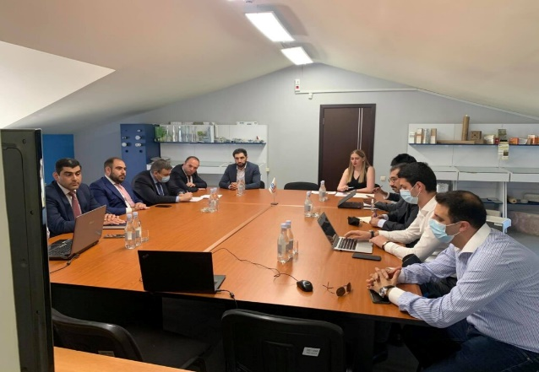 On June 7, a meeting- discussion on the investment project of the 200 MW Aig-1 solar photovoltaic plant was held at The Renewable Resources and Energy Efficiency Fund of Armenia. The members of the bidding commission, RA Deputy Minister of Territorial Administration and Infrastructure Hakob Vardanyan, and the bidders took part in the discussion. A number of issues related to the competition were discussed.

**Working meeting**

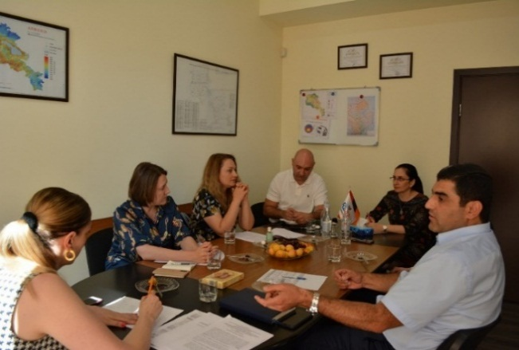

On July 26 a working meeting was held with the delegation of the Eurasian Fund for Stabilization and Development at the Renewable Resources and Energy Efficiency Fund of Armenia. During the visit, Fund Director Karen Asatryan and staff discussed with representatives of the delegation the terms of launching the grant project "Mechanisms for Improving Energy Efficiency in Public Buildings and Promoting the Development of Green Energy". As part of the project, it is planned to implement energy-saving measures in about 20 state-funded institutions (schools, hospitals).

**Meeting with science-oriented history teachers of Pushkin School N8 in Yerevan**

On August 6, within the framework of the "Green Skills for Youth" project implemented in Armenian schools by the Renewable Resources and Energy Efficiency Fund of Armenia, a meeting-discussion with science-oriented teachers of the Pushkin School N8 in Yerevan was held.

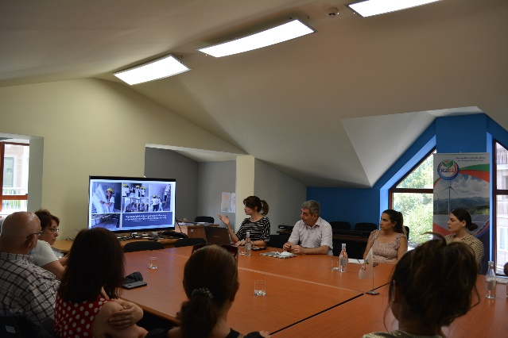 The project, using the potential of school teachers, aims to raise awareness of green technology among students.

 Nune Sakanyan, president of the Women in Climate and Energy NGO, presented the project, the work done within it, and the results achieved. Fund expert Yeremia Yengibaryan presented the working principle of the 7 kW solar photovoltaic system installed at the school within the framework of the project and the technology used.

During the meeting, they discussed the measures envisioned to visually convey practical knowledge about energy saving, energy-efficient technologies, practical operation, and usefulness of the solar photovoltaic plant to teachers, students, and parents.

**Discussion-Meeting**

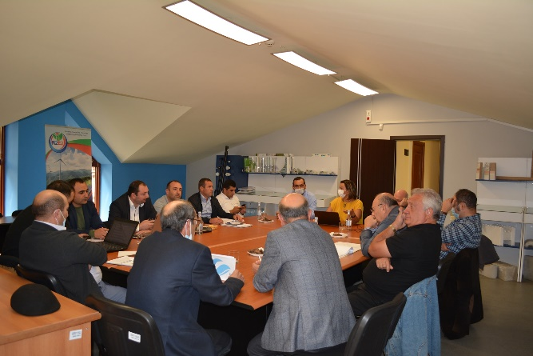

On October 4 the Renewable Resources and Energy Efficiency Fund of Armenia held a discussion meeting on the construction of a 600kW solar power plant in Artik within the framework of the EU4Energy - Armenia project. The project is implemented by the Energy Efficiency Fund, the contractor of the project is “ECO VILLE”, the designer is “JINJ” LLC, and the technical supervision of the project is carried out by the Renewable Resources and Energy Efficiency Fund of Armenia. Within the framework of the project, a discussion meeting was organized, during which the experts of the companies participating in the project discussed the current issues of construction, the work done, and the planned next steps.

**Public hearings**

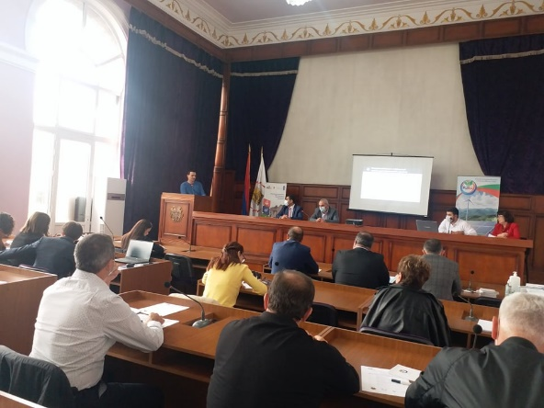Public hearings on the environmental and social consequences of the construction of a 250 kW floating photovoltaic power plant on Lake Yerevan were held in the conference hall of Yerevan's Shengavit district on October 6.

The meeting was attended by Gevorg Nazaryan, Head of Environmental Protection Department of Yerevan Municipality, the project stakeholders, representatives of state bodies, representatives of environmental NGOs, as well as representatives of the French organization TRANSENERGIE, partner of the Renewable Resources and Energy Efficiency Fund of Armenia.

During the meeting, the importance of the project, its progress, and the next steps was presented. All questions of the parties on the construction site were answered exhaustively, as well as the suggestions and concerns expressed by the parties, which will be taken into consideration for further design work.

**Opening of a solar photovoltaic plant in Yerevan**

On October 21, a solar photovoltaic plant was installed on the roof of Pushkin Elementary School No. 8 in Yerevan.

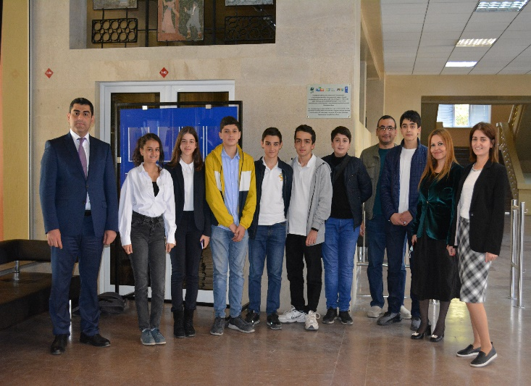The installation of a 7kW school solar power plant was carried out within the framework of the “Green” Skills for Youth project of the “Women in Climate and Energy” NGO, funded by the UNDP-GEF Small Grants Project and the Renewable Resources and Energy Efficiency Fund of Armenia.

The construction of the plant was led by EcoVille company.

Opening remarks were delivered by Karen Asatryan, Director of the Renewable Resources and Energy Efficiency Fund of Armenia., and Nune Sakanyan, President of the Women in Climate and Energy NGO.

School students presented their knowledge about Armenian and global energy developments, renewable energy, construction of solar plants, and the plant installed on the roof of the school․ Natalia Stepanyan, director of the Yerevan basic school N 8 named after A. Pushkin, gave a speech of thanks.

**Opening of a solar photovoltaic plant in Gyumri**

On October 26, the opening of the solar PV plant installed on the roof of primary school No. 7 in Gyumri, Shirak Marz, RA took place. 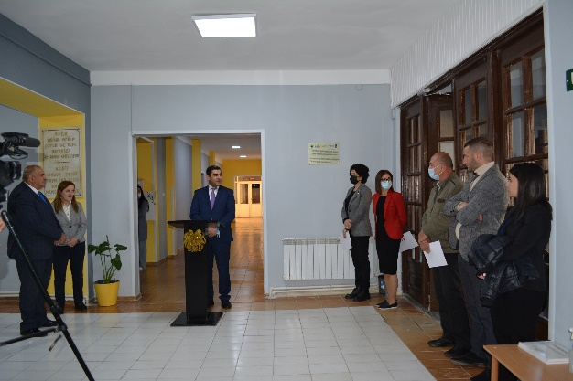

The installation of a 10kW school solar power plant was carried out within the framework of the “Green” Skills for Youth project of the “Women in Climate and Energy” NGO, funded by the UNDP-GEF Small Grants Project and the Renewable Resources and Energy Efficiency Fund of Armenia. The construction of the plant was carried out by Shtigen company.

School director Gagik Karapetyan and physics teacher, head of the school's "Green Team" Susanna Simanyan made opening remarks

School students presented their knowledge about Armenian and global energy developments, renewable energy, construction of solar plants, and the plant installed on the roof of the school․

Karen Asatryan, director of the Renewable Resources and Energy Efficiency Fund of Armenia, and Nuneh Sakanyan, president of the Women in Climate and Energy NGO, spoke about the importance of students' education and knowledge about renewable energy, energy-saving, and the environment.

The director of the school gave letters of thanks to all the experts who contributed to the construction of the plant and for introducing the students to the field of renewable energy.

**"Energy Week" measure**

On October 27, Karen Asatryan, Director of the Renewable Resources and Energy Efficiency Fund of Armenia, took part in the "Energy City" hackathon organized within the Energy Week measure in the Yerevan Municipality, during which he presented the financial mechanisms of Energy Efficiency and Renewable Energy.

**Electric vehicle charging plant**

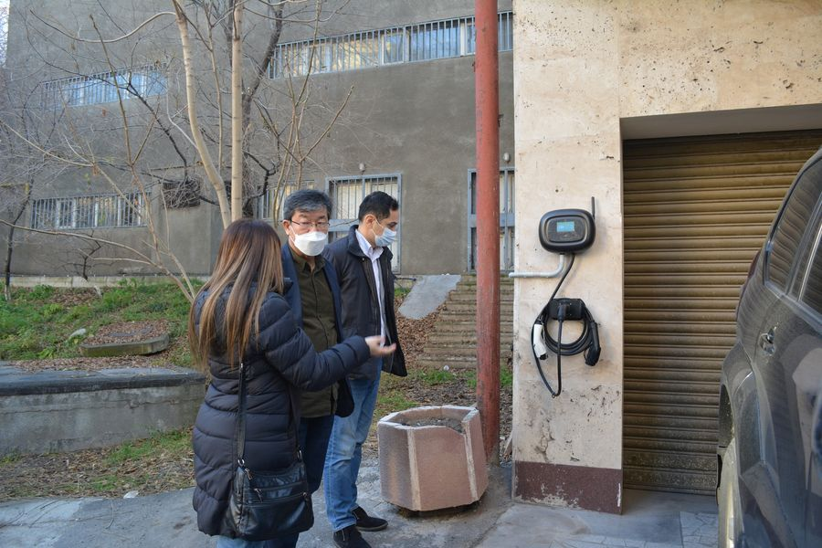

the Renewable Resources and Energy Efficiency Fund of Armenia installed an electric vehicle charging plant within the framework of the Japan International Cooperation Agency's (JICA) Small Grants Project.

As a leader in green technology in Armenia, the R2E2 Fund constantly contributes to the achievement of Armenia's sustainable development goals and the implementation of environmentally-friendly measures.